Shaheed Bhagat Singh
State Technical Campus, Ferozepur
(Established and promoted by Govt. of Punjab)

Supplementary Agenda
of
27th Meeting of the Finance Committee
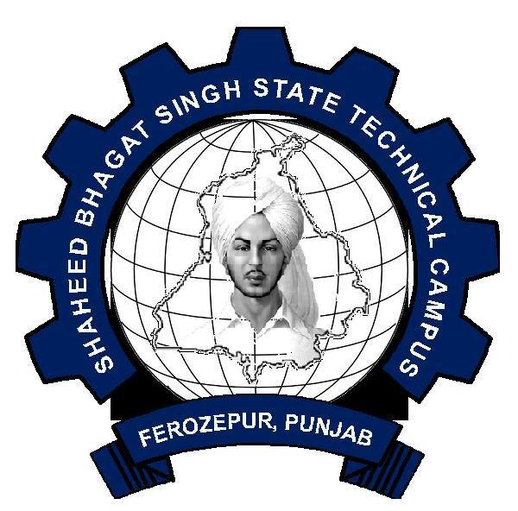

VENUE: Office of the Principal Secretary to Government of Punjab,
Department of Technical Education & Industrial Training , 5TH Floor, Mini Secretariat, Sector-9, Chandigarh
.
DATE: 28.01.2014
TIME: 11.30 AM

CONSTITUTION OF THE FINANCE COMMITTEE

1. | Principal Secretary to Govt. of Punjab,  Deptt. of Technical Education & Industrial Training  Chandigarh | Chairman
2. | Principal Secretary of Govt. of Punjab,  Deptt. of finance or his representative  (not below the rank of Jr.Secretary) | Member
3. | Director,  Deptt. of Technical Education & Industrial Training, Punjab  Chandigarh | Member
4. | Director,  Shaheed Bhagat Singh State Technical Campus, Ferozepur | Member
5. | Registrar,  Shaheed Bhagat Singh State Technical Campus, Ferozepur | Member-Secretary

CONTENTS

ITEM NO PARTICULARS PAGE NO

27.23(I) To consider the attachment of services of Sh Gaurav Kumar, Administrative 01
Officer with Honable Minister, Local Bodies, Govt of Punjab

27.23(II) To approve the collaboration with Netherland based organization PUM 02

27.23(III) Restoring of Grant-in-Aid…… Regarding 03

Item No.27.23(i) To consider the attachment of services of Sh. Gaurav Kumar, Administrative officer withHon’ble Minister, Local Bodies, Govt. of Punjab.
Sh.Gaurav Kumar Administrative Officer joined his duty on 8.5.2013 (A/N) in Polytechnic Wing of Shaheed Bhagat Singh State Technical Campus, Ferozepur. His Head Quarter was shifted from Ferozepur to Chandigarh to have proper co-ordination between the Institute and other departments such as AICTE, New Delhi, Govt of Punjab, PTU Jalandhar & TEQIP vide o/o No. SBS/FZR/2032 dated 11.7.2013. Besides, he was also directed to have a close ligision with the office of the then Hon’ble TEM cum Chairman, Society of SBSSTC. Copy is placed at Ann. I on page 4 . Later on, in September 2013, Sh. Anil Joshi Ji became Hon’ble Minister for Local Bodies Govt. of Punjab, Medical Education and Research & Sh. Madan Mohan Mittal became as Hon’ble Minister Govt of Punjab for Industry and commerce, Technical Education and Industrial Training, Parliamentary Affairs. On 01.10.2013, Hon’ble Minister for local Govt, Medical Education & Research wrote DO letter to Hon’ble Minister for Industry and commerce, Technical Education and Industrial Training, Parliamentary Affairs for permission of continuity the services of Sh. Gaurav Kumar Administrative Officer with him.( Copy is placed at Ann.II on Page No.5. Director, Technical Education & Industrial Training Pb. Vide Memo No. 1782/S-2/ECC/2013 dated 30-10-2013 asked the college to take up the matter with B.O.G. for approval. Copy is placed at Annexure III on page No. 6.
As the meeting of B.O.G. was not fixed, the matter was put up to Hon,ble Chairman, B.O.G. for approval subject to ratification in the next meeting of B.O.G. But it was kept pending for want of discussing the issue with Hon,ble Minister Local Govt. Copy is placed at Annexure IV from page No. 07 to 09.
Again, Director, Technical Education & Industrial Training Pb. Vide Memo No. 2009/S-2 / ECC/ 2013 dated 24-12-2013 asked to report the action taken on the subject. Accordingly this office informed about taking the matter in the next meeting of B.O.G. Copies are placed at Annexure V on page 10. As the meeting of B.O.G is yet to take place, the matter is placed before the Finance Committee for consideration.

-1-

Item No.27.23(ii) To approve the Collaboration with Netherland based organization PUM
The institute had applied to a Netherlands government supported organization called “PUM” for providing support to SBSSTC Ferozepur to enhance the employability of students and offer global exposure to its faculty and students. PUM had accepted our request and deputed one of its senior experts, Dr. Jan Borkent, to visit the institute for three weeks (03-08-2013 to 24-08-2013). Accordingly the matter was put up in the 15th meeting of B.O.G. vide its Agenda item No. 15.16 for allowing the Institute to have collaboration with PUM (Netherland Based organization). After detailed deliberation, it was decided to put up the complete proposal in the next meeting of Finance Committee. The complete report of the project is placed at Annexure VI from Page No.11 to 33 .
Now Dr. Ajay Kumar, Associate Professor has put up a proposal for allowing two faculty to visit Netherland under the Business Link Programme. The total cost for visit of two persons comes to Rs. 365000/- which includes lodging and boarding’s. A copy of the proposal submitted by Dr. Ajay Kumar, Associate Professor is placed at Annexure VII from page 34 to 36 .
The matter is placed before the committee for consideration.

-2-

Item No. 27.23 (iii) Restoring of Grant-in-aid --- Regarding
Institute has got a grant of Rs. 10.00 Crores from MHRD. Government of India under TEQIP-II project. The institute has already received Rs. 2 crores and receiving of Rs. 5 crores is in the pipeline.
The main objectives of TEQIP project are as below:-
1. The institute must get academic autonomy within the period of project.
2. The institute must get the eligible branches accredited.
3. The institute must get updated to the status of deemed University.
To fulfill the above said objectives, the institute is pursuing the case on was footing. For getting the academic autonomy, institute has applied through PTU to UGC New Delhi. However, the UGC has given the Recognition to this institute under Section -2f of the UGC Act 1956 but, kept the institute in the category of Unaided/Self-financing institutes and accordingly, Institute is not eligible to receive Central Assistance under Section-12(B) of the UGC Act 1956 (Annexure VIII –Page 37). As and when institute will be upgraded as Autonomous Institute /Deemed University, then institute will not be eligible to receive central assistance under Section -12(B) of the UGC Act 1956.
Therefore, the matter is put-up before the finance Committee to put-up a proposal before the Government of Punjab for getting regular financial grant in order to avail Central Assistance under Section-12(B) of the UGC Act. 1956.
Submitted for consideration and approval please.

-3-

